Roslyn Packer Theatre Access Information
Download this page as a PDF or Word.doc here.

Bookings or Enquiries
If you have access or seating requirements, please call our Box Office on (02)
9250 1999 to book your tickets or ask any questions you may have. We will select
seats to suit your needs, as these seats are unable to be booked online. Please
specify your requirements at the time of booking to make best use of our services.

National Relay Service
Those customers who are Deaf or hard of hearing can call through the National
Relay Service at no cost:

TTY users, phone 133 677 then ask for 9250 1999

Internet relay users, connect to the NRS – see www.relayservice.com.au for
details, then ask for 9250 1999

Getting Here
Drop off points
There is a drop off and pick up point directly outside the theatre. There is also a taxi zone 15m from the front door. Please note that it is not permitted to park cars in these spaces as they are strictly for drop offs and pick-ups only. Patrons can be met here by a staff member if they require use of one of the courtesy wheelchairs, or staff assistance. For staff assistance, please request this service at the time of booking. Staff can assist patrons either 1 hour 15 mins prior to show, or 45 mins prior (Box Office staff will confirm this with you if/when you make your booking).

Parking
Wilson Car Park operates three car parks in the near vicinity of the Roslyn Packer Theatre. The closest Car Park is Bond Store One, located at 26 Hickson Road, Walsh Bay.

Bond Store One
Vehicle access is via 26 Hickson Road.
There are 2 accessible bays for RTA Mobility Parking Permit Holders on the first level just past entry. There are lifts nearby with level access to Hickson Road.

Barangaroo Point Car Park
Vehicle access is via Hickson Road.
There are 4 accessible bay for RTA Mobility Parking Permit Holders; 3 on blue level and 1 on yellow level. The accessible car spots are near the lifts which have level access to the street.

Barangaroo Reserve Car Park
Vehicle access is via Towns Place.
There are 8 accessible parking spaces for RTA Mobility Parking Permit Holders. There are 4 on level B1 and 4 on level B2. These spots are close to the lifts, with level access to the street.

On Street Parking
A limited number of on-street metered parking spots are available along Hickson Road outside the Roslyn Packer Theatre and outside The Wharf.
There are also eight dedicated accessible street parking bays at the following locations:
- Two at Towns Place, close to the entry to the Car Park (approx. 150m walk)
- Two on Hickson Road, outside the Roslyn Packer Theatre (approx. 20m walk)
- Four on Hickson Road opposite Pier One Hotel (approx 500m walk)
See a map of accessible street parking locations here.
Unfortunately these spaces cannot be booked.

Staff assisted access
You may wish to have one of our front of house staff assist you. Please see one of our friendly staff at the Cloakroom for assistance. The Cloakroom is located next to the Box Office.

There are also 3 courtesy wheelchairs available to assist patrons from the kerb to the foyer. If you require to be met kerbside with a wheelchair before the show, please call the Box office on (02) 9250 1777 or see one of our helpful front of house staff at the cloakroom on the day of the show (Our Cloakroom is located on the ground floor, left of the Box Office).

By Train or Ferry
Circular Quay railway station, bus and ferry terminus is the closest public transport hub. Roslyn Packer Theatre is a 1.7km walk (without stairs) from Circular QuayStation. To get to the theatre from the station, walk along the footpath around Circular Quay towards the MCA and turn left after the MCA. Then turn immediate right onto George Street until you get to Hickson Road. Turn right on Hickson Road and follow the road around the bend until you get to the Roslyn Packer Theatre.

By Bus
Roslyn Packer Theatre can be reached by the 311, 324 and 325 bus services. These buses all stop 100 metres away from the Roslyn Packer Theatre on Hickson Road towards Barangaroo. See map here.
To check on updates to your bus services please visit transportnsw.info or phone 131 500.

Wheelchair Accessible Information
Street Access
The Roslyn Packer Theatre’s main entrance is via Hickson Road. There is a level accessway from the street leading into the ground floor foyer.
Box Office Access
Our Box Office is located on the ground floor, in the foyer of the Roslyn Packer Theatre. The Box Office is accessible via street level and is approximately 10m from the main entrance doors.
Lifts
There is lift access to all levels of the Roslyn Packer Theatre. The lift is aacross the foyer on the ground floor, approximately 15m from the main entrance doors.

Accessible Seating
Wheelchair seats are available in the Roslyn Packer Theatre. There is level access from the main entrance into the theatre.
Accessible Toilets
There are two accessible toilets at the Roslyn Packer Theatre.
One is located on the Ground Floor, with level access from the theatre and Hickson Road. The toilet is opposite the entry to the lift on the ground floor, adjacent to the male toilets.
A second accessible toilet is available on level 2, adjacent to the women’s toilets.
Cloakroom
Our Cloakroom is located on the ground floor, in the foyer of the Roslyn Packer Theatre, to the left side of the Box Office nearest the Lift. The Cloakroom is complimentary and is accessible via street level and is approximately 12m from the main entry doors.

Information for patrons with low vision
Viewing Distances
The distance from the middle of the stage to the centre of the rows listed below is as follows:
Stalls
Row AA: 2.1 metres
Row BB: 3. 1metres
Row A- 4.2 metres
Row B- 5.1 metres
Row C- 6.1 metres
D- 7.1 metres

Please discuss your specific requirements at the time of booking your tickets with Box Office staff directly on 9250 1777 or by emailing boxoffice@sydneytheatre.com.au. Please note that Stalls rows AA, BB, and A are not always available - these are released on a production by production basis based on staging requirements. You may be offered a front row seat in BB, A or B Row depending on your performance selection.

Assistance animals
Assistance animals are permitted into the auditorium. Please mention this upon booking and you’ll be offered an aisle seat, and told about any special effects that might affect your animal’s comfort.

Audio described performances
A selection of audio-described performances are presented each year. Audio-description is a live commentary by trained describers, interspersed with the actors’ dialogue. Description is relayed via a discreet headset linked to the infrared audio system. Some of these performances include a workshop and tour of the set prior to the performance, to enable vision impaired patrons to familiarise themselves with the physical aspects of the production.
Audio-described performances must be booked via telephone. Please call our Box Office on (02) 9250 1777 and specify your requirements at the time of booking. When booking for an audio-described performance, please let us know the number of headsets you require. Headsets should be collected before the performance from the Box Office.
Find a list of current audio-described performances available here
Information for patrons who are deaf or hard of hearing
Assisted listening devices
A narrow cast FM system is available at the Roslyn Packer Theatre in both the Stalls and the Dress Circle. Headsets contain FM receivers and can be used by patrons with or without hearing aids. To use the loop system, please request a headset from our Front of House staff via the Cloakroom situated next to the Box Office in the Ground Floor Foyer.

Captioned performances
Captioning allows those persons that are hard of hearing to follow the on-stage dialogue in real time. Sydney Theatre Company uses plasma screens for this purpose. The screens are visible from selected seats in the Roslyn Packer Theatre.
If you wish to be seated in this area for these productions, please call Box Office on (02) 9250 1777 to book your tickets. We ask that you specify your needs at the time of booking to ensure you have the best possible experience.
Find a list of currently available captioned performances here.

Auslan Interpreted performances
STC offers Auslan-Interpretation for a selection of performances throughout the year. Auslan is the Australian sign language used by people who are deaf or hard of hearing. During an Auslan Interpreted performance, one or two interpreters are positioned side-stage, relaying the dialogue spoken by the actors, into sign language in real time.
For each Auslan-interpreted performance, the best seats in which to view the interpreter and stage are reserved for these patrons.
If you wish to be seated in this area for these performances, please call Box Office on (02) 9250 1777 to book your tickets. Please specify your requirements at the time of booking to make use of this service.
Find a list of STC’s Auslan-interpreted performances here.

Bookings for deaf or hard of hearing patrons
Patrons who are hard of hearing can call through the National Relay Service at no cost:
- TTY users, phone 133 677 then ask for 9250 1777
- Internet relay users, connect to the NRS – see www.relayservice.com.au for details, and then ask for 9250 177

Stair Access
Patrons are advised that the Roslyn Packer Theatre has steps between the Ground Floor and Level One. If using the stairs, patrons should note the following steps need to be climbed to reach each level from the foyer.
Ground Floor Level 1 (25 steps)
Level 1 Level 2 (25 steps)

If you require assistance please discuss your requirements with our friendly box office team at the time of booking tickets.

Access to Walsh Bay Kitchen
Entry to Walsh Bay Kitchen restaurant is through level access via the ground floor foyer or via the restaurant’s Hickson Road entrance.

Foyer Bars
There are two theatre bars at the Roslyn Packer Theatre. One is located on the ground floor, adjacent to the stairs, and the other is on level one, also adjacent to the stairs. Both have level access from the lifts, and are nearby to the lifts.
Avoid the queues by pre-purchasing your interval drinks on arrival. Pre- order at one of the theatre bars, and collect your drinks from the same location at interval.

Parents Room
There is a change table facility in the accessible bathroom on the ground floor.

Map
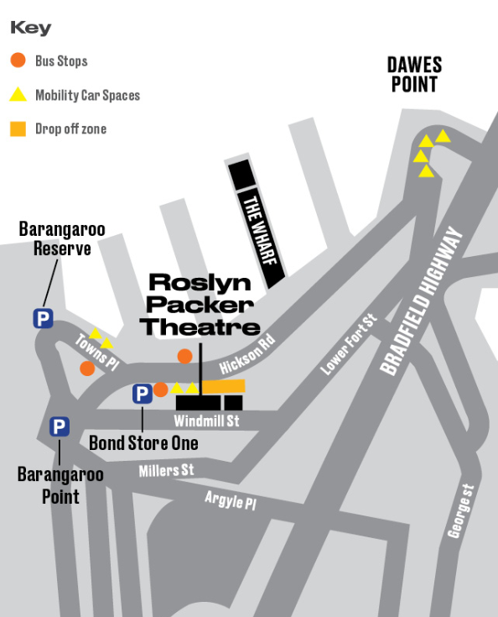

We’re here to help
Please contact the STC Box Office to discuss your particular needs so we can ensure your comfort and enjoyment.
Phone (02) 9250 1777

TTY users, phone 133 677 then ask for 9250 1777

Internet relay users, connect to the NRS – see www.relayservice.com.au for details, then ask for 9250 1777
Email boxoffice@sydneytheatre.com.au
BUS STOP
311, 324, 325
BUS STOP
311

